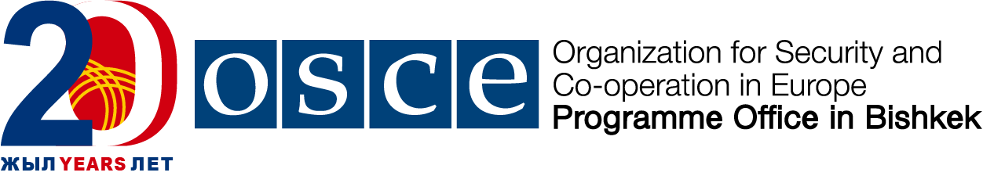

Kick off meeting: Information sharing among international organizations on OGP
Date: Thursday, 14 March 2019
Venue: Programme Office in Bishkek
6 Ryskulov Str., Bishkek, Kyrgyz Republic

Opening  10.00 – 10.15 | Opening remarks  - Dr. Pierre von Arx, Ambassador, Head of the OSCE Programme Office in Bishkek;  - Mr. Bakyt Satybekov, Co-chair of the OGP National Forum  Moderator: Eni Gjergji, Acting Head of Economic and Environmental Dimension
10:15- 10:30 | Overview of the current implementation of the OGP process in the Kyrgyz Republic and plans for 2019  - Mr. Bakyt Satybekov, Co-chair of the OGP National Forum
10.30– 11:30 | Tour de table: international organizations’ 2019 ongoing/ planned support to the Kyrgyz Government on the OGP process.  - International Organisations present  Moderator: Eni Gjergji, Acting Head of Economic and Environmental Dimension  Topics for discussion:  - Support on the implementation of the OGP National action Plan;  - Planned outreach and awareness raising activities on the OGP process;  - Support in building constructive dialogue between state bodies and civil society;  - Support on OGP Parliament.
11:30 – 11.50 | Exploring potential formats for further effective cooperation/ coordination.  - International Organisations present  Moderator: Eni Gjergji, Acting Head of Economic and Environmental Dimension
11.50 – 12:00 | Closing remarks

